Login/ New Registration on Rajasthan State Pollution Control Board

Step 1: Open the web site http://rspcbmis.environment.rajasthan.gov.in/ now click on Sign In button if you need help for login then click on user manual.

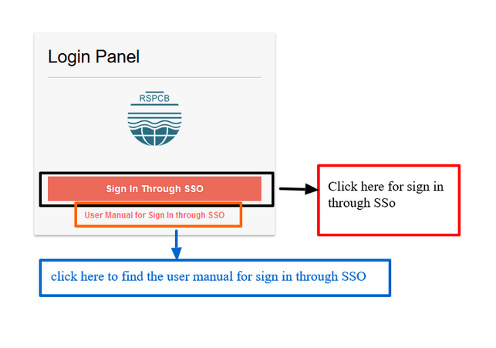

Step 2: Login on SSO by using a user id and password that is created on past.
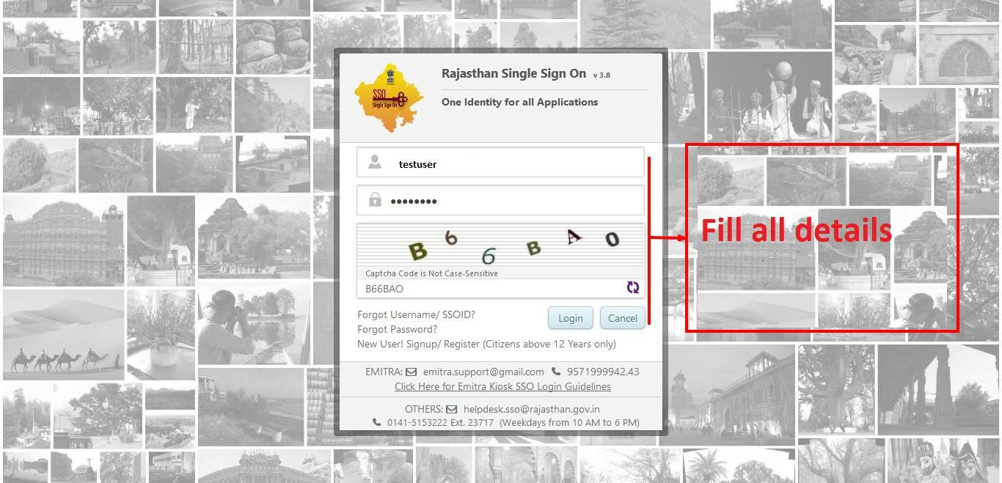

Step 3: If you do not have SSO id then clicks on new User signup.

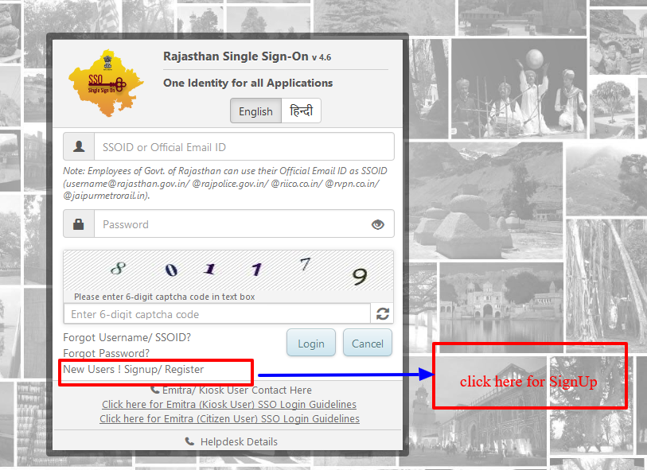
Step 4: For new registration you can use the any id like Bhamashah or Aadhaar card or you can also login through your facebook id or Gmail id.

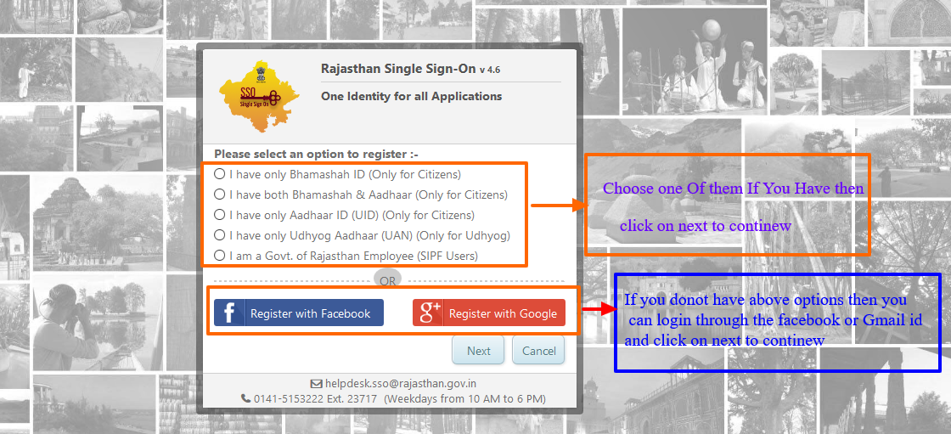

Step 5: If you choose register with Google then:-

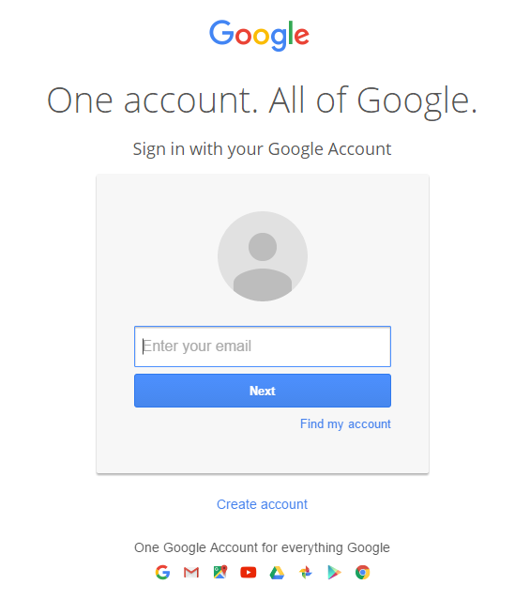

Step 6: Choose a valid user name and password and this user id will be created on SSO

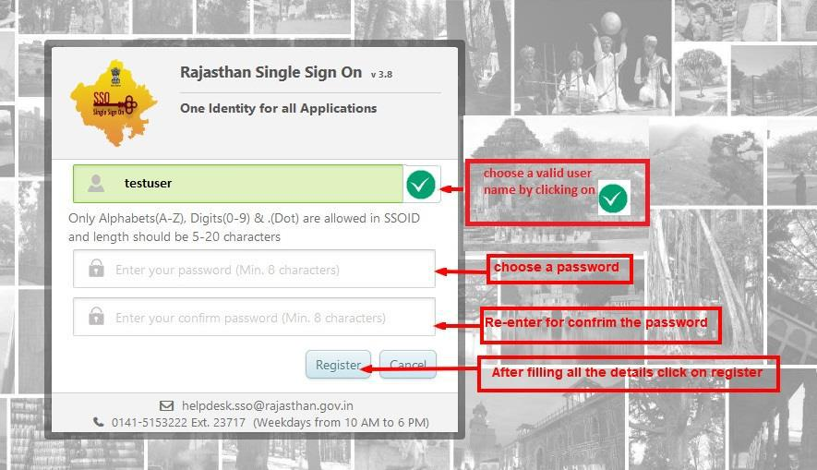
Step 7: Click on RSPCB that will redirect on Rajasthan State Pollution Control Board.
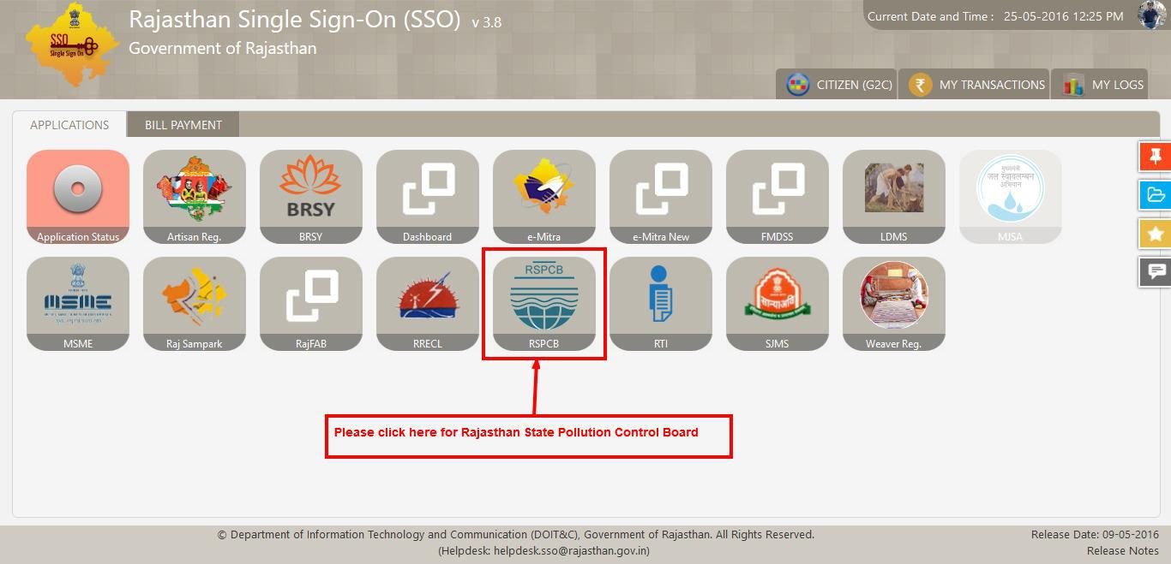

Step 8: Now two options will be appears so you can choose yes if you already registered with Rajasthan State Pollution Control Board or chose NO if you are not registered with Rajasthan State Pollution Control Board.

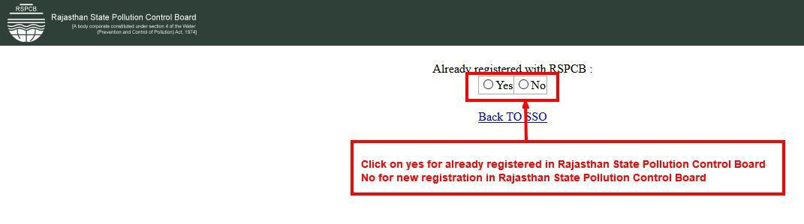

Step9: if you choose yes then fill the all valid details and click on sigh in to continue after the successful login the dashboard will be appear that is showing in step no. 11.
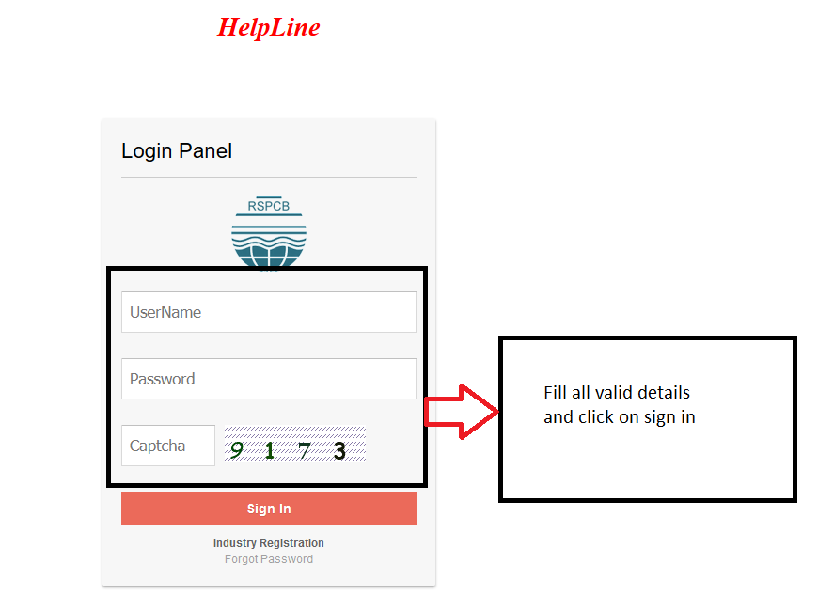

Step 10: If you chose No then a registration form will be display then fill all the required details, there is some details like First Name, Mobile no, Email Address that will be auto fill that is coming through SSO so you cannot change at this time and click on save.

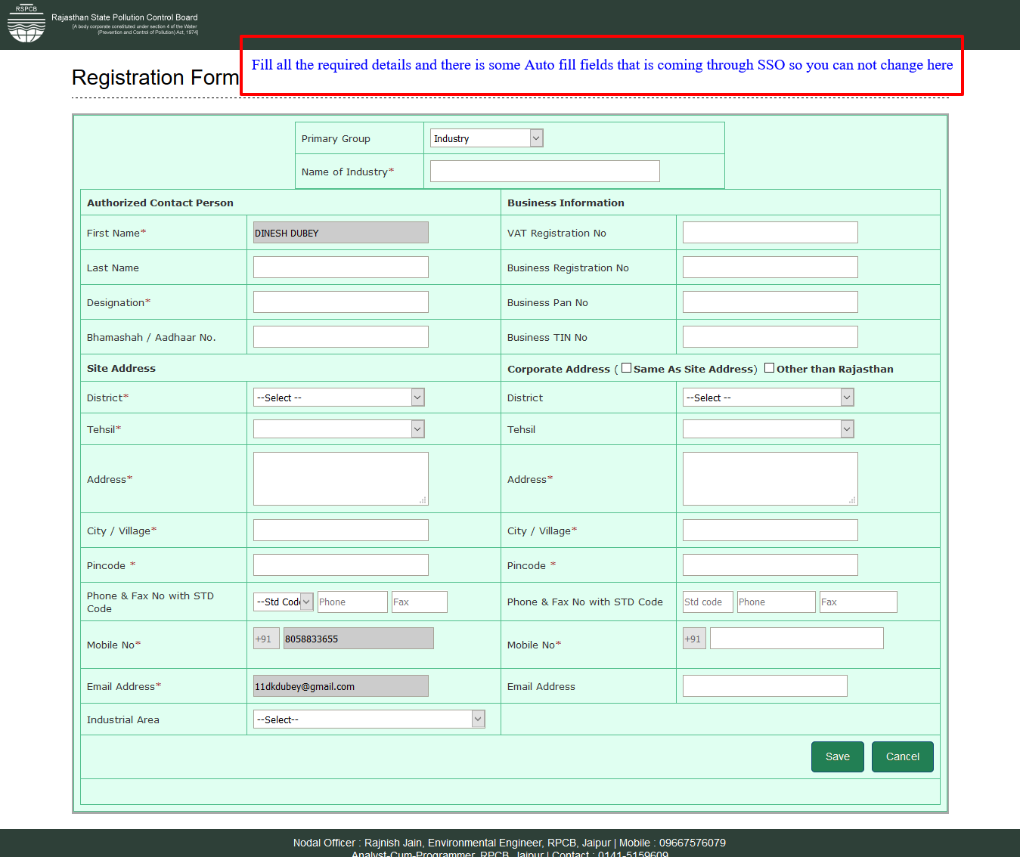
Step 11: After the successful login the Dashboard will be appear there is some information that is user specific.

